**MONGODB ASSIGNMENT**

1.Retrieve all products in the "Electronics" category

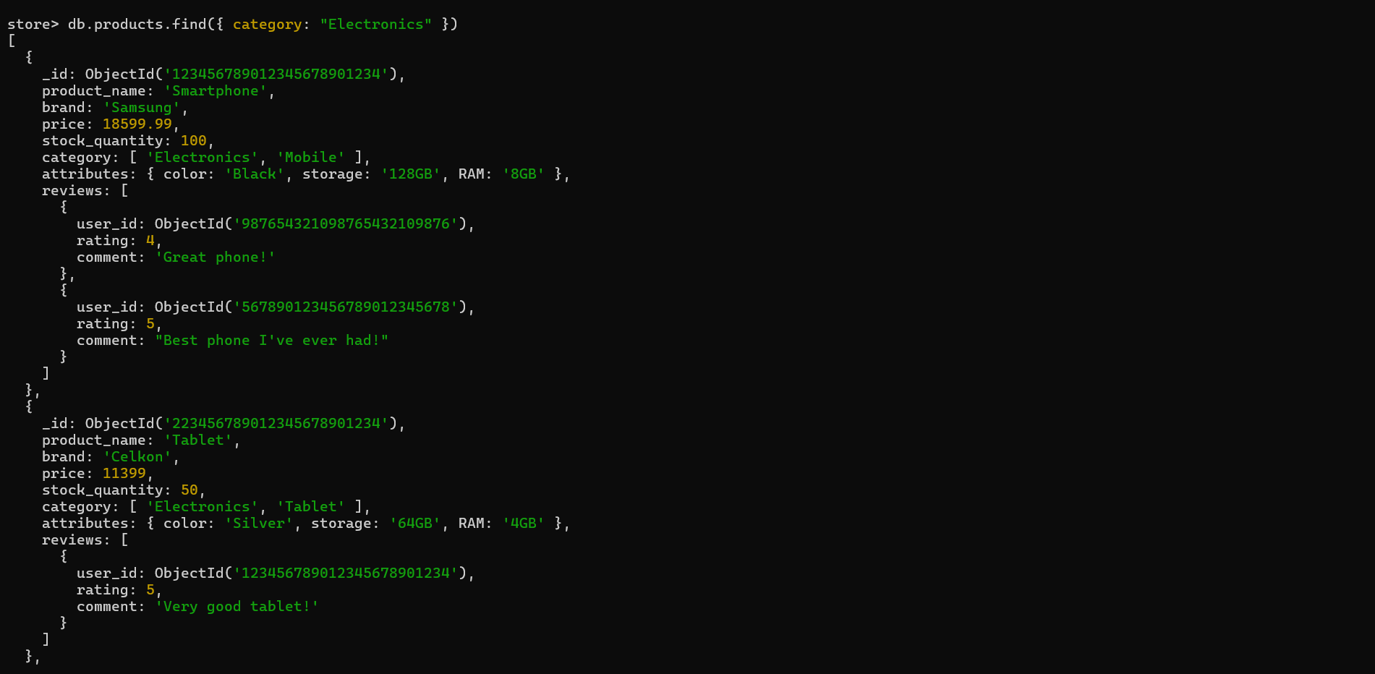

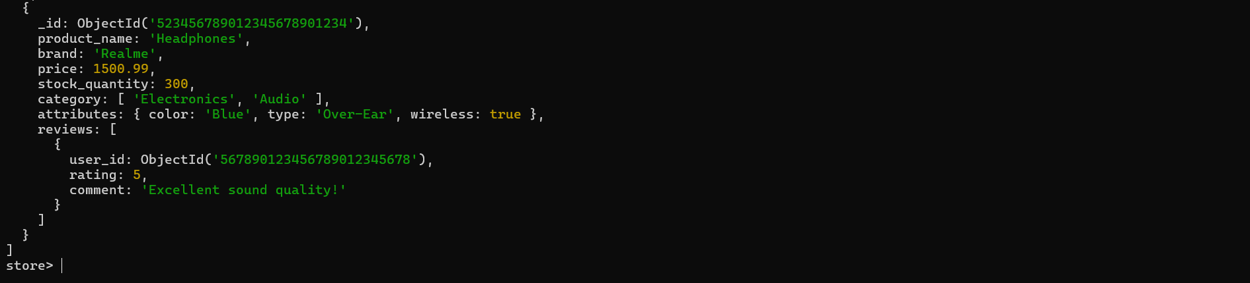

2. Find all products with a price less than $500.

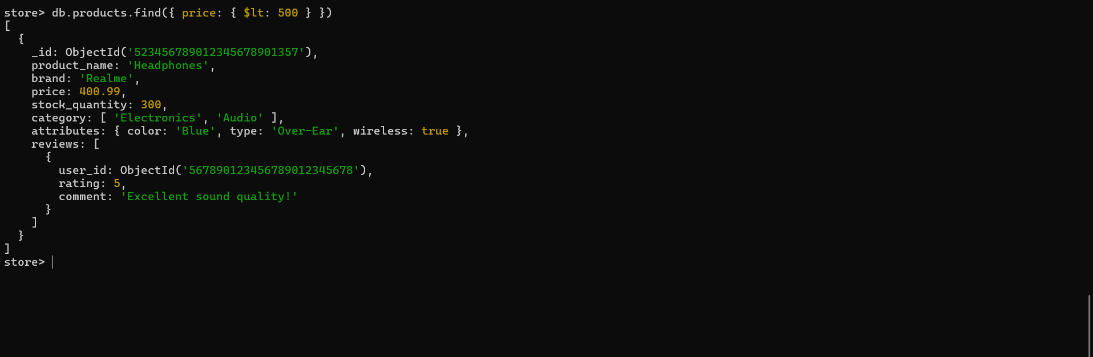

3. Retrieve all products with a rating greater than 4.

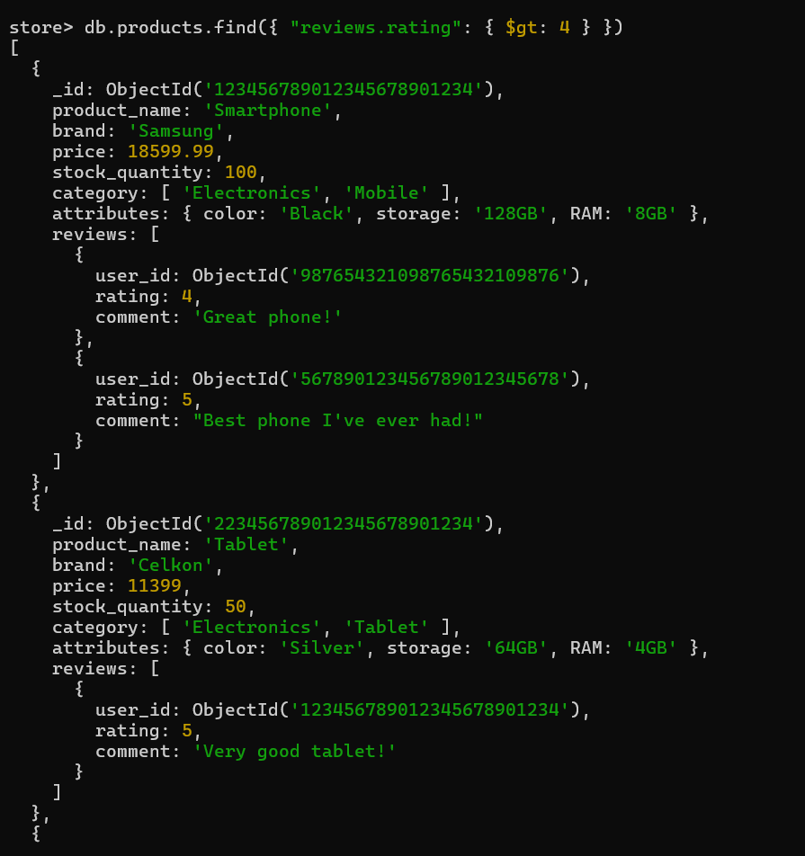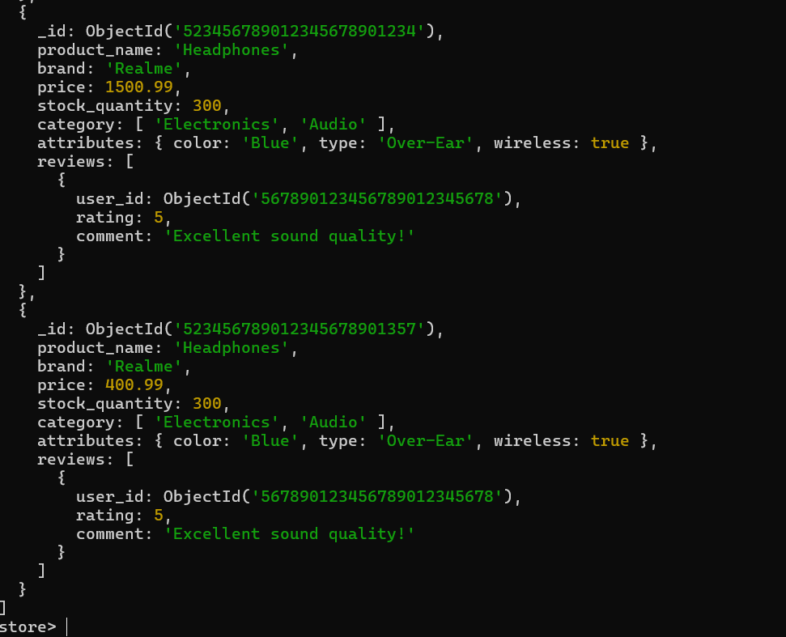

4. Find all productswith a specific color (e.g., Black).

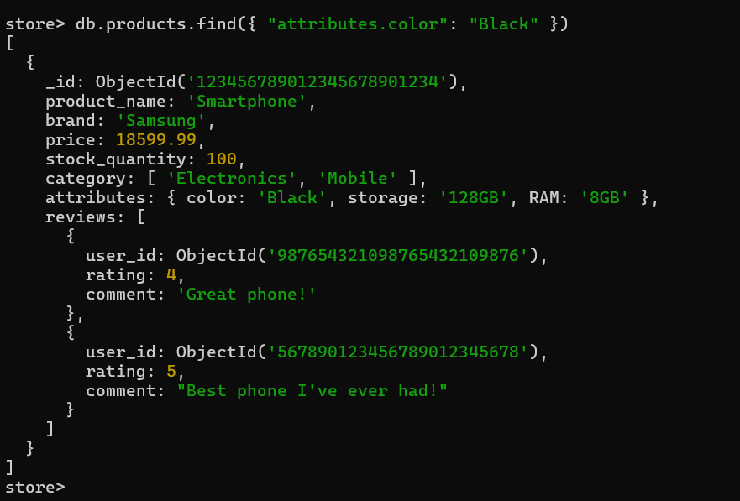

5. Retrieve all products sorted by price in descending order.

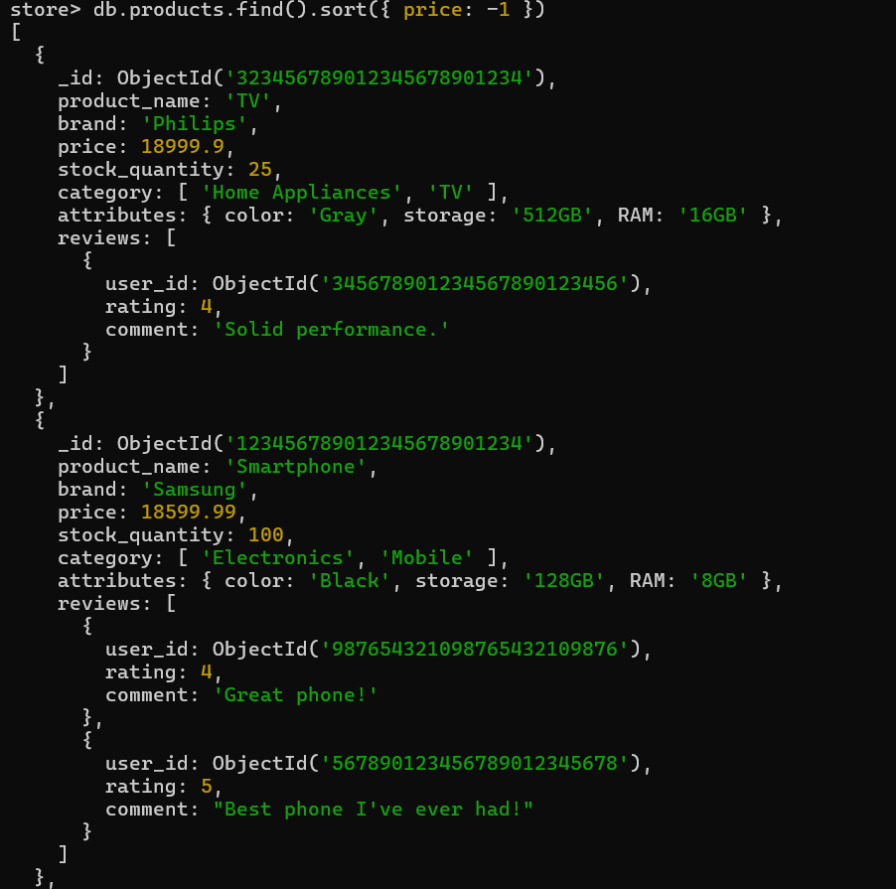

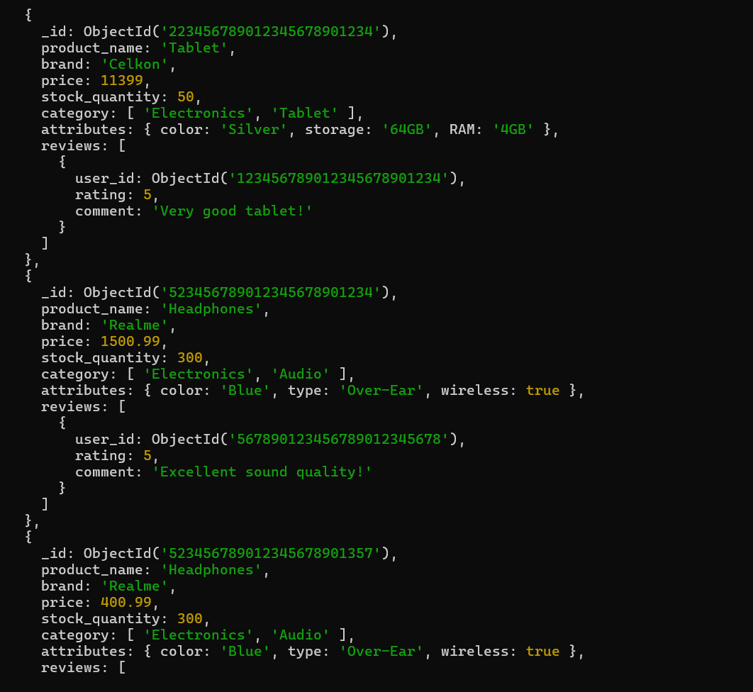

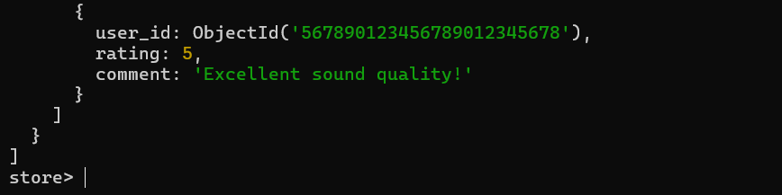

6. Calculate the average rating of all products.

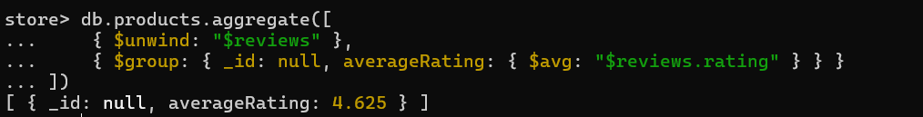

7. Find all products where the stock quantity is less than 10.

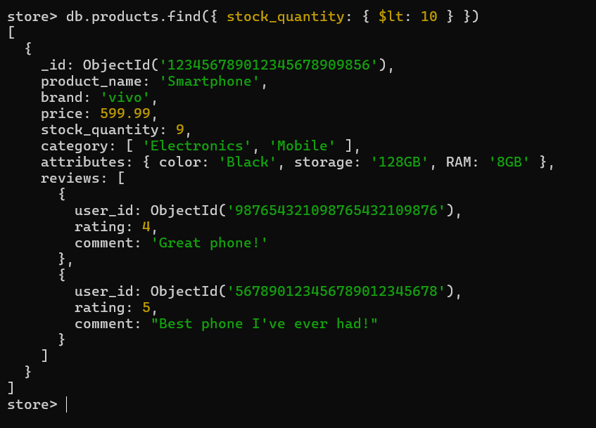

8. Retrieve all products with a specific brand (e.g., BrandX).

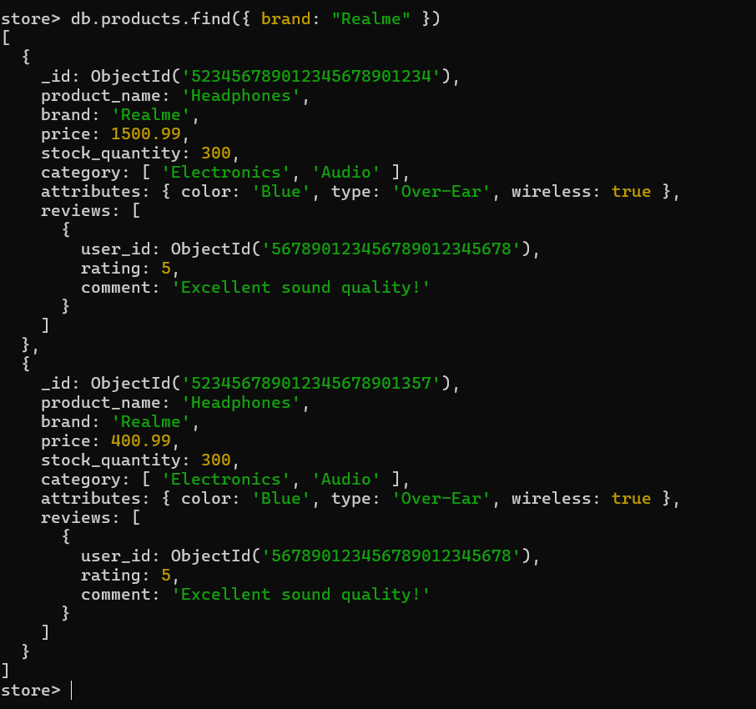

9. Find all products where the storage is 128GB and RAM is 8GB.

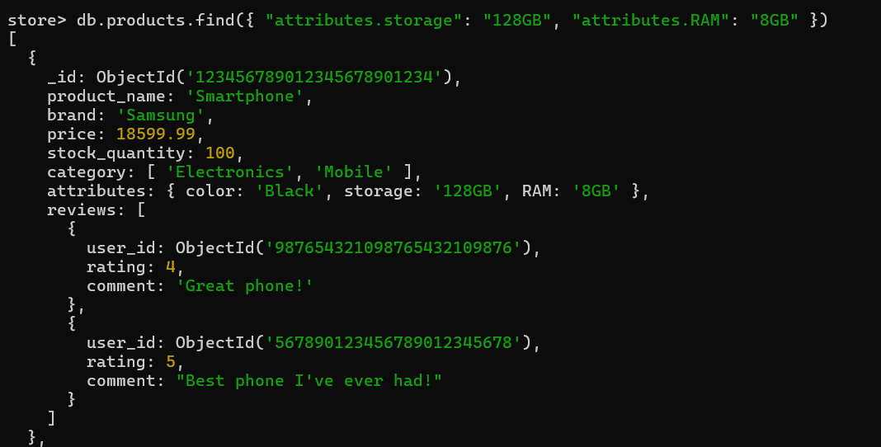

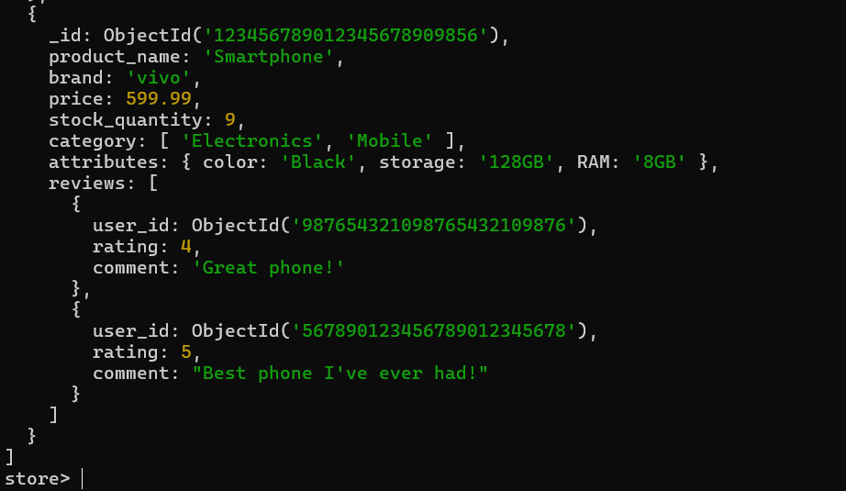

10. Retrieve all products with a specific user's review (e.g.,user_id:ObjectId("987654321098765432109876")).

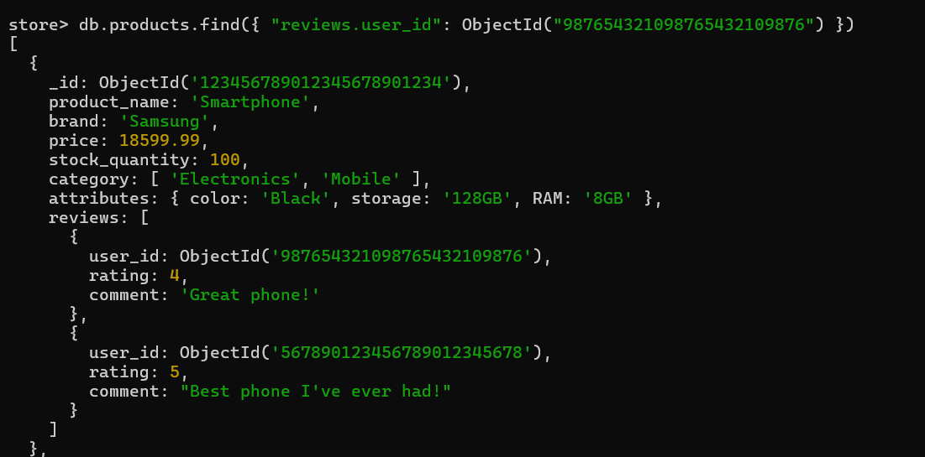

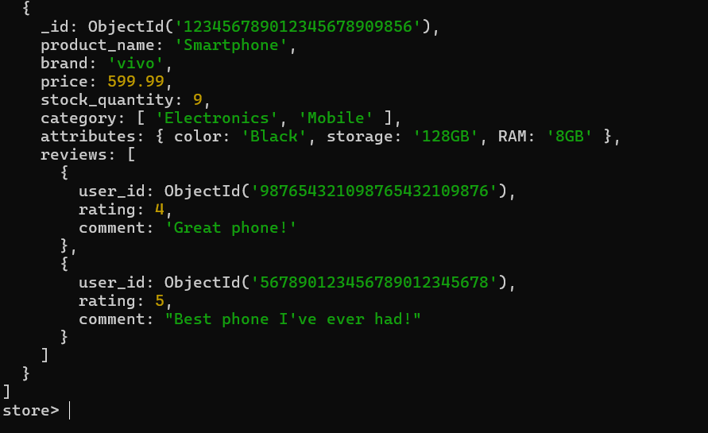

11. Calculate the total number of reviews for each product.

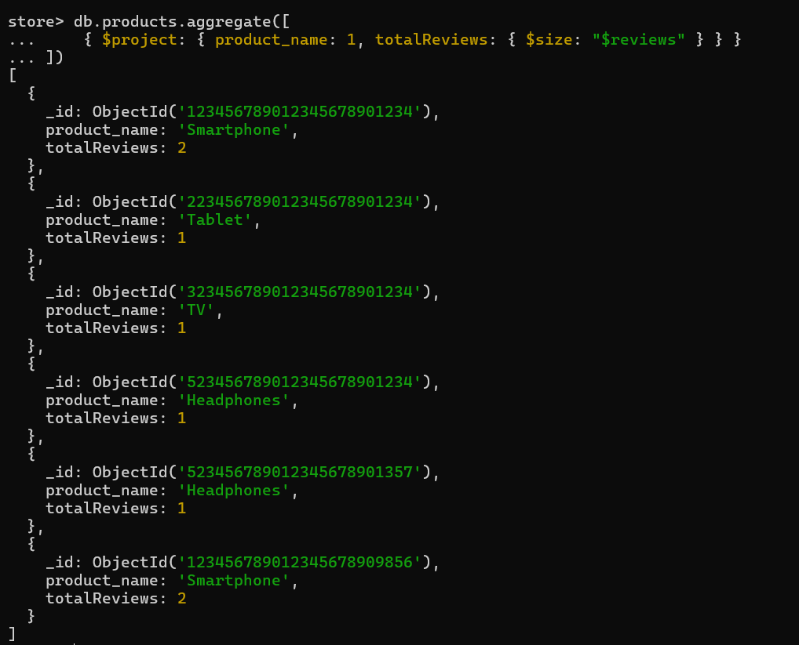

12. Find all products with a price between $400 and $600.

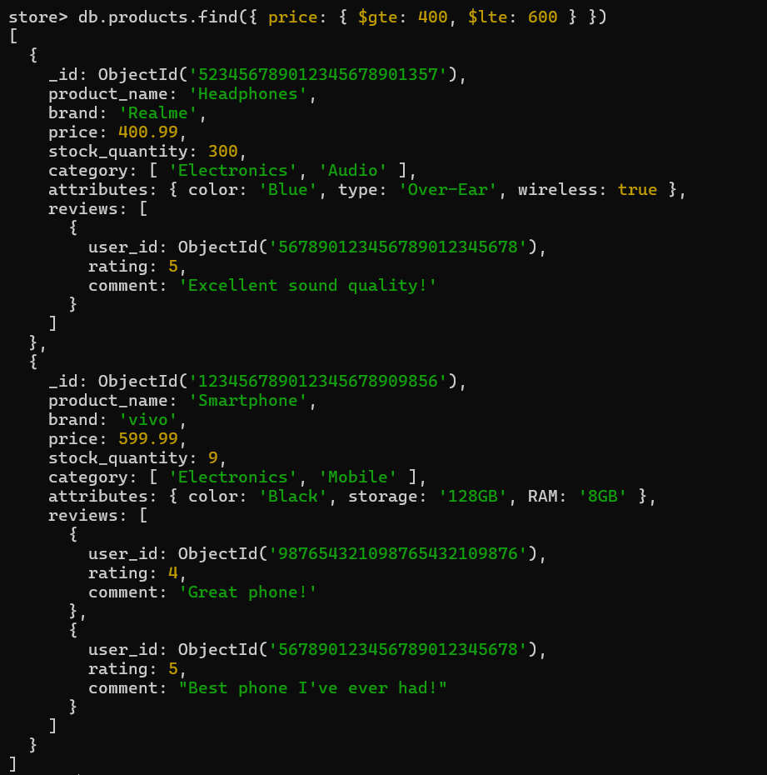

13. Find all products with a specific category (e.g., "Mobile") and a stock quantity greater than 50.

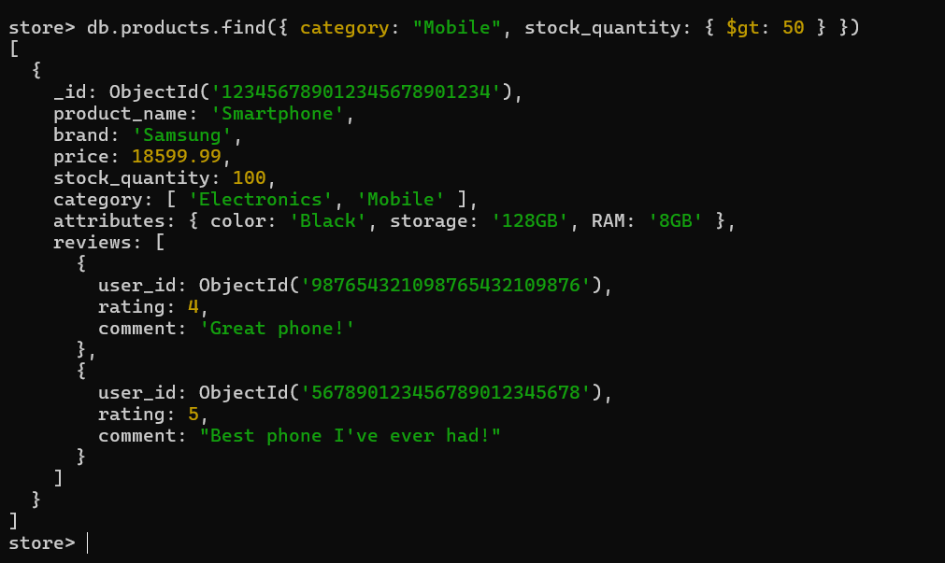

14. Find the highest rated product.

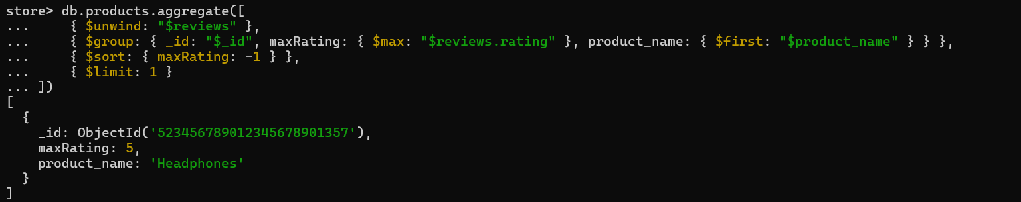

1. 15. Retrieve all products sorted by brand in ascending order and then by price in descending order.

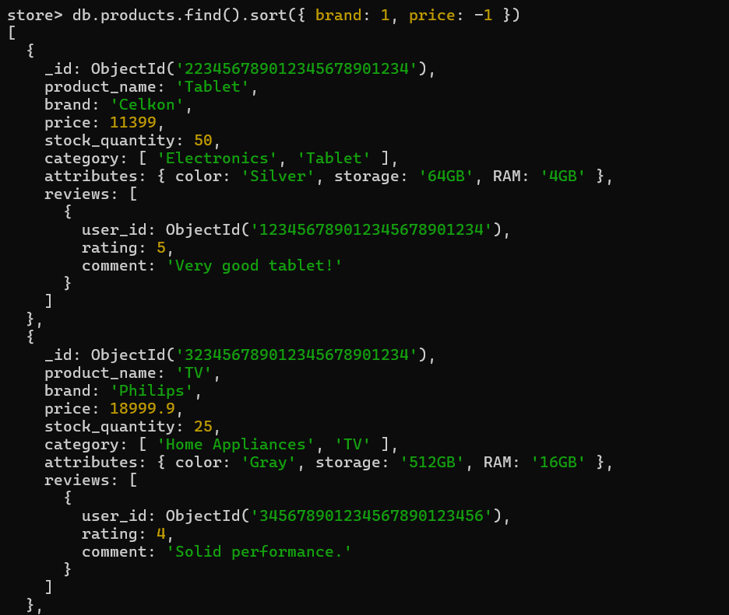

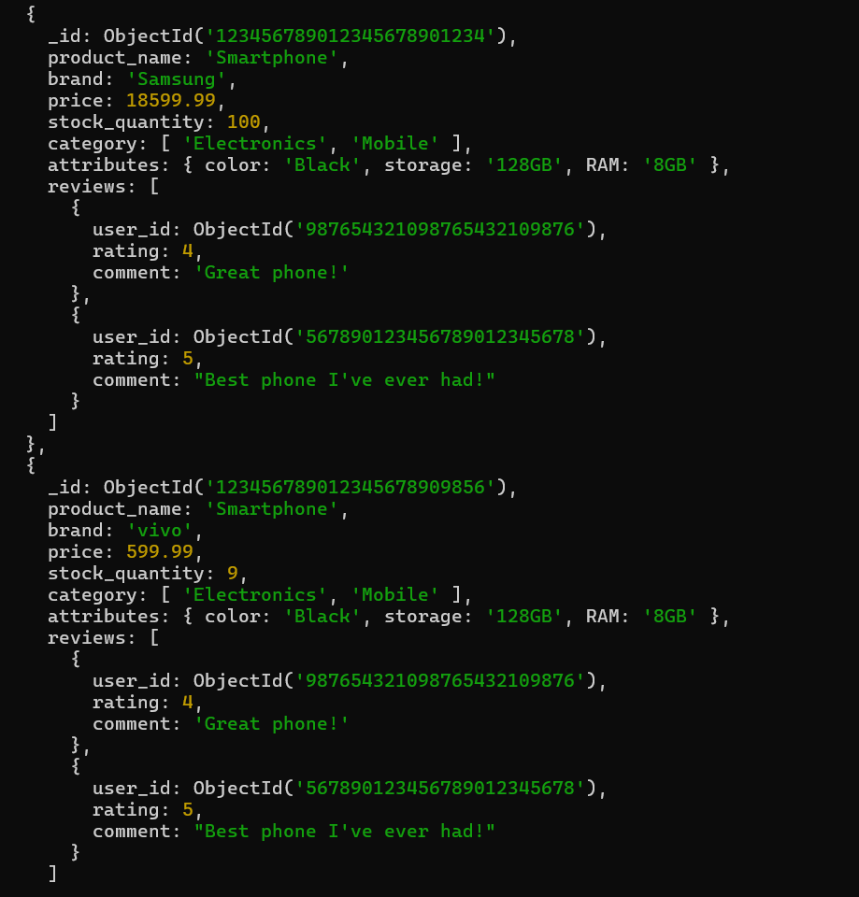

16. Find all products with a specific comment in their reviews (e.g., "Great phone!").

